Mail or fax back attention SHINE
The Annual Medicare Part D Open Enrollment is October 15-December 7
Every year plans change. We can help you determine the best plan option available for you.

(Please fill out this information according to how it appears on your Medicare health Insurance Card)

First Name Click here to enter text. Middle Click here to enter text. Last Click here to enter text. Suffix Click here to enter text.

Address Click here to enter text. City Click here to enter text. State Click here to enter text. Zip Click here to enter text.

Day-time Phone Number Click here to enter text. Alternate Phone Number Click here to enter text.

Date of Birth Click here to enter text. Medicare Claim Number Click here to enter text.

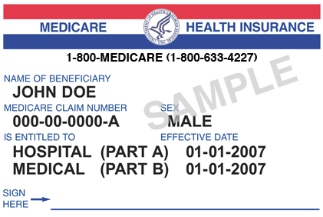
Effective Date Part A Click here to enter text. Effective Date Part B Click here to enter text.

What prescription drug plan do you currently have? Click here to enter text.

Are you satisfied with your current plan? Yes Click here to enter text. No Click here to enter text.

What is the name of your pharmacy? Click here to enter text.

Please answer the following to determine if you are eligible for assistance

Do you have MassHealth? Click here to enter text. Do you have Prescription Advantage? Click here to enter text.

How many people in your household? Click here to enter text. What is your monthly household income? Click here to enter text.

Amount of assets (savings accounts, stocks, etc)? Click here to enter text.

List of medications (if you have more medications or questions, please use the back of this form)

Name | Dosage | Frequency
Click here to enter text. | Click here to enter text. | Click here to enter text.
Click here to enter text. | Click here to enter text. | Click here to enter text.
Click here to enter text. | Click here to enter text. | Click here to enter text.
Click here to enter text. | Click here to enter text. | Click here to enter text.
Name | Dosage | Frequency
Click here to enter text. | Click here to enter text. | Click here to enter text.
Click here to enter text. | Click here to enter text. | Click here to enter text.
Click here to enter text. | Click here to enter text. | Click here to enter text.
Click here to enter text. | Click here to enter text. | Click here to enter text.
Click here to enter text. | Click here to enter text. | Click here to enter text.
Click here to enter text. | Click here to enter text. | Click here to enter text.
Click here to enter text. | Click here to enter text. | Click here to enter text.
Click here to enter text. | Click here to enter text. | Click here to enter text.
Click here to enter text. | Click here to enter text. | Click here to enter text.
Click here to enter text. | Click here to enter text. | Click here to enter text.
Click here to enter text. | Click here to enter text. | Click here to enter text.
Click here to enter text. | Click here to enter text. | Click here to enter text.
Click here to enter text. | Click here to enter text. | Click here to enter text.
Click here to enter text. | Click here to enter text. | Click here to enter text.
Click here to enter text. | Click here to enter text. | Click here to enter text.

Questions: | Click here to enter text.

